## Introduction

The Cedar Mini Joystick is a small USB joystick that can act as either an HID gamepad or as a mouse. It has a relatively small range of motion and a moderately low force required. In Joystick mode, it is compatible with the Xbox Adaptive Controller.

## Features

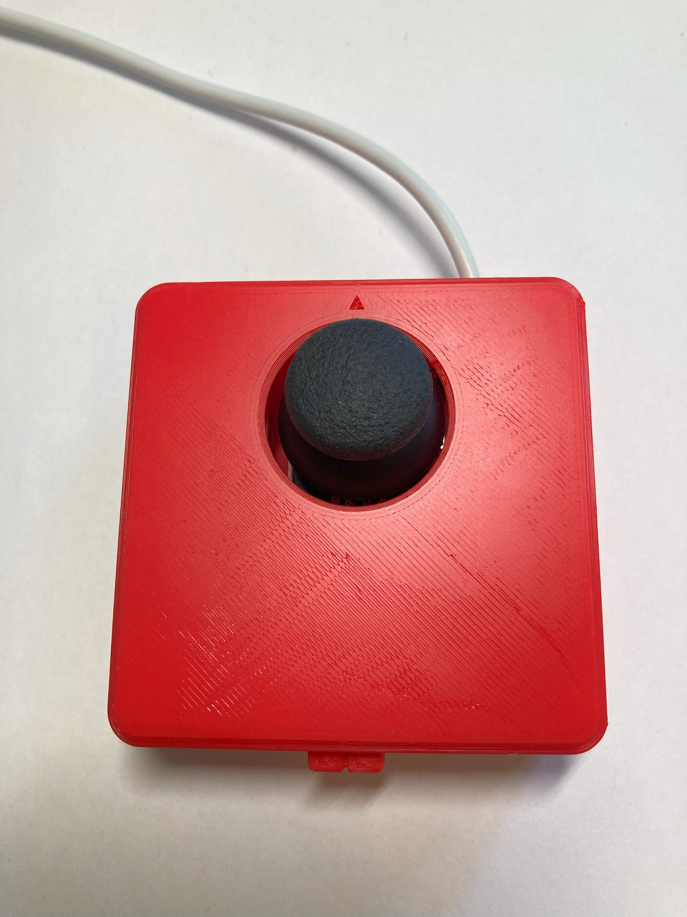

Joystick

Arrow indicating “up” direction on joystick

USB cable exit

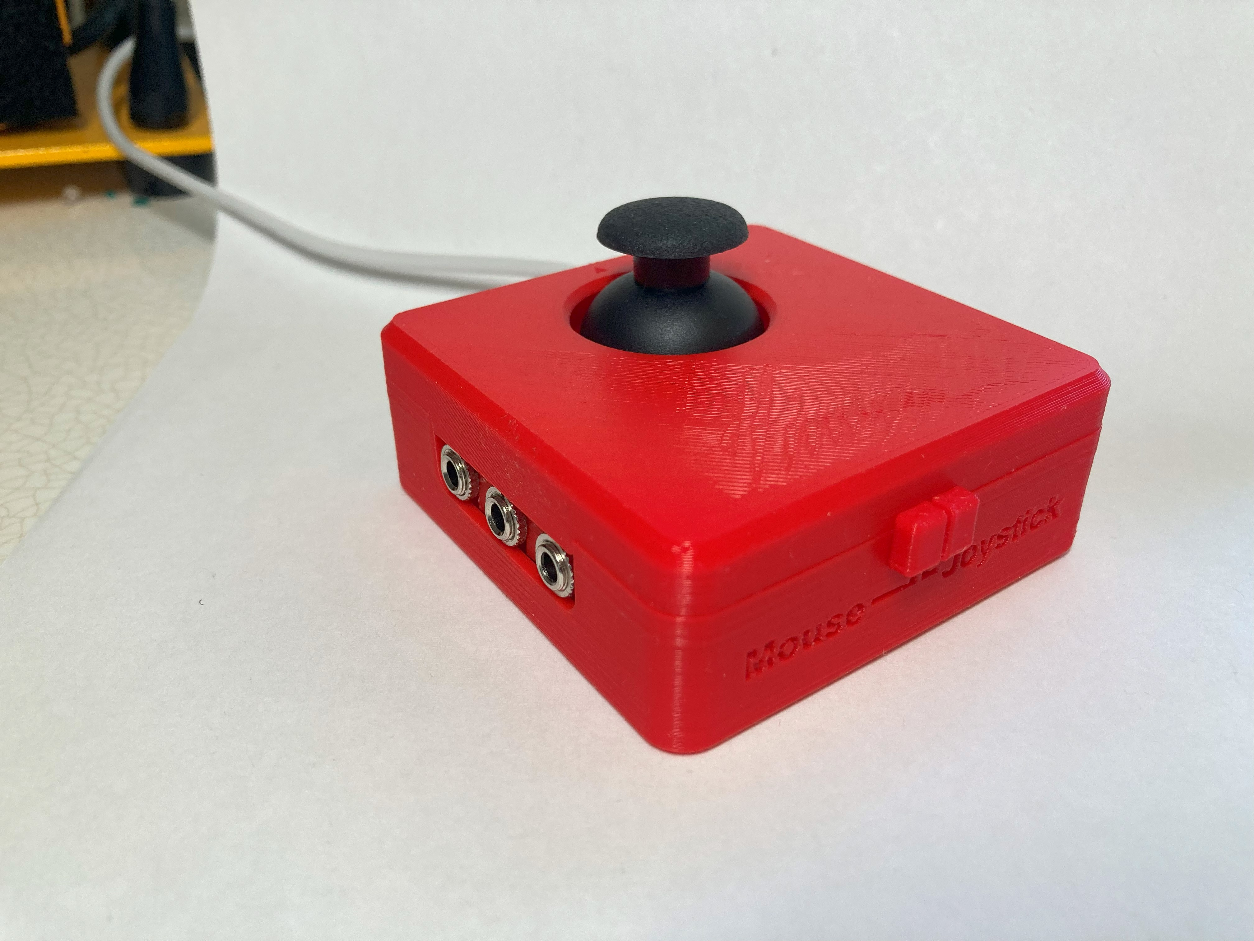

Assistive switch jacks

Mode switch

### Mode Switch

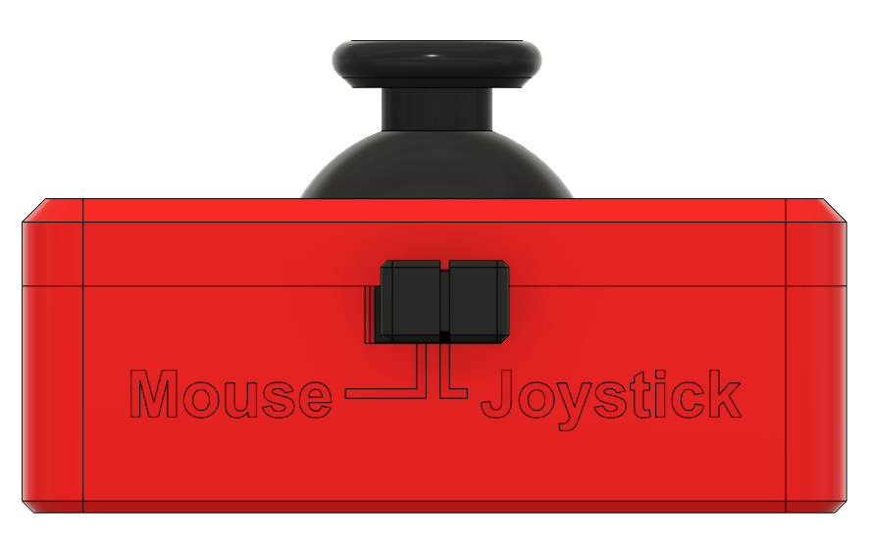

### Assistive Switch Jacks

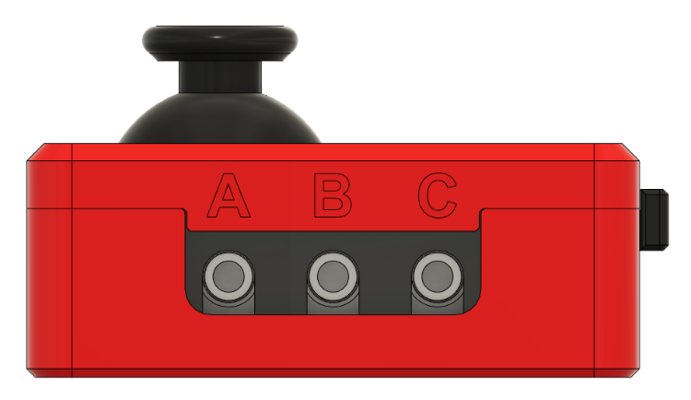There are three jacks on the side of the joystick for plugging in assistive switches. They are labelled from left to right as A, B, C.

### Mounting Holes

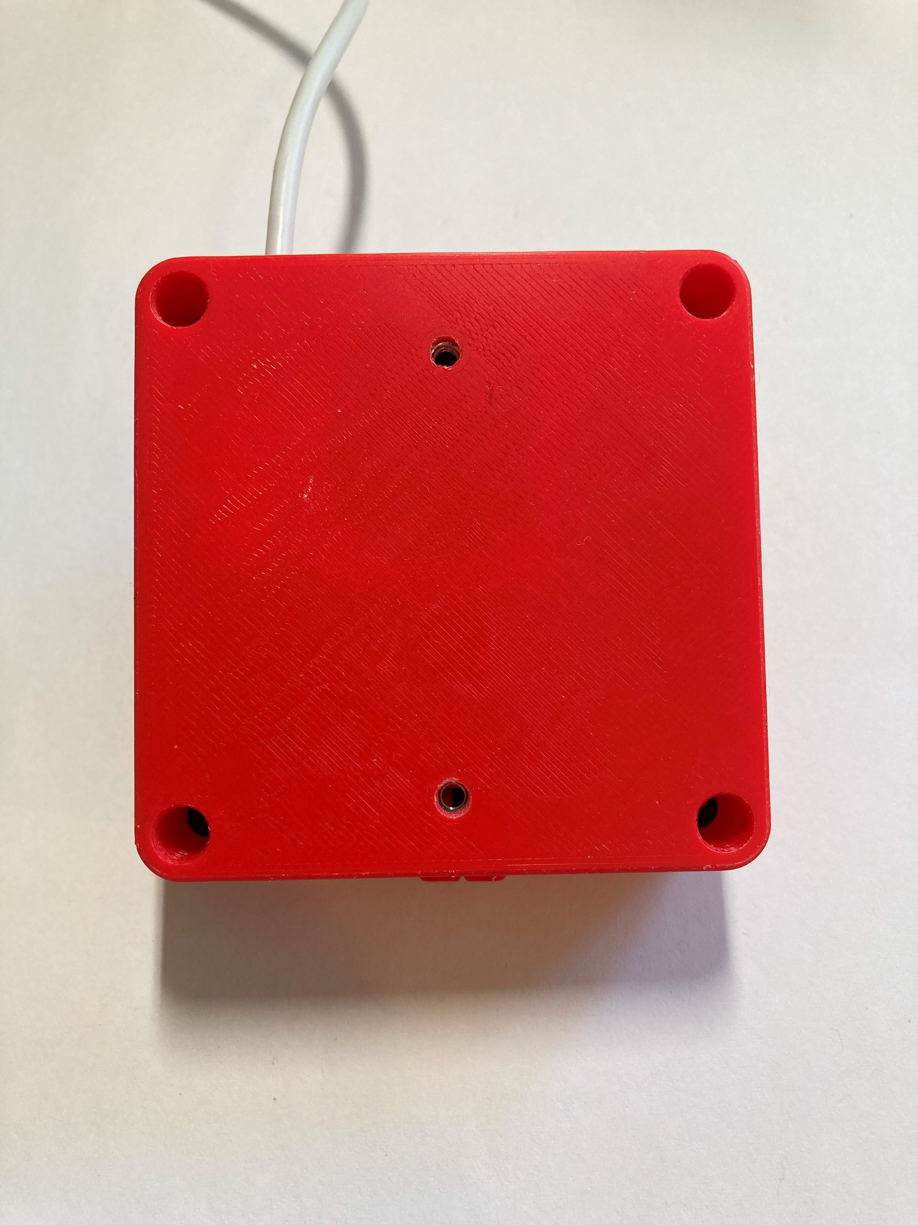

Screw holes for mount adapters

## Compatibility

Mouse mode – compatible with PC. It should also be compatible with Android and Apple phones and tablets but this has not been tested.

Joystick mode – compatible with PC (direct or gaming with Steam) and with Xbox Adaptive Controller (XAC). Through the XAC it is compatible with PC and Xbox directly, or can be used with other gaming consoles with adapters. It should also be compatible with Android phone and iPhone but has not been tested.

## Usage

**For Mouse Mode:**

1. Move the slide switch to the left for Mouse Mode, as indicated on the housing.
2. Plug in assistive switches to the switch jacks. The default switch mapping is stated below.
3. Plug the joystick into the device you wish to use it with.
4. Orient the joystick so the arrow on top is facing away from the user and the cable is exiting the enclosure away from the user.
5. Move the joystick to move the mouse, use the switches for the functions listed below.

**For Joystick Mode:**

1. Move the slide switch to the right for Joystick Mode, as indicated on the housing.
2. If desired, plug in assistive switches to the switch jacks. The default switch mapping is stated below.
3. Plug the joystick into the device you wish to use it with.
4. Orient the joystick so the arrow on top is facing away from the user and the cable is exiting the enclosure away from the user.
5. Move the joystick to move the mouse, use the switches for the functions listed above.
6. Depending on what device you are using the joystick with, if you are using switches plugged into the jacks you will most likely want to remap them. This can be done in your system’s settings.

**To Switch Modes:**

1. Unplug joystick
2. Slide the mode switch to the desired mode
3. Plug in the joystick to host device

### Mapping

|  |  |  |  |  |
| --- | --- | --- | --- | --- |
| **Cedar** | **Mouse** | **Joystick** | | |
| **PC** | **XAC (Left USB)** | **XAC (Right USB)** |
| Joystick | Mouse movement | Joystick | Left thumbstick | Right thumbstick |
| A | Left click | Button 1 | X1 | View |
| B | Middle click (scroll) | Button 2 | X2 | Menu |
| C | Right click | Button 3 | Left stick (left press) | Right stick (right press) |
| Joystick push down | Left click | Button 4 | Left bumper | Right bumper |

### Mounting the Joystick

#### Tabletop – Hook and Loop Fastener

|  |  |
| --- | --- |
| One way the joystick can be mounted, is on a tabletop or other surface such as a lap tray, and fastened using a hook and loop fastener such as Velcro.  Typically, best practice is to stick the side with the loops (the softer side) to the tabletop or other surface, and to stick the side with the hooks (rough side) to the joystick. | Bottom of the joystick with hook and loop fastener attached to the bottom. The hook side is shown stuck to the joystick. |

#### Tabletop – Non-slip pads

Another way the joystick can be use on the tabletop is by using a non slip material, such as the no slip stoppers shown below, or a non slip material such as Dycem.

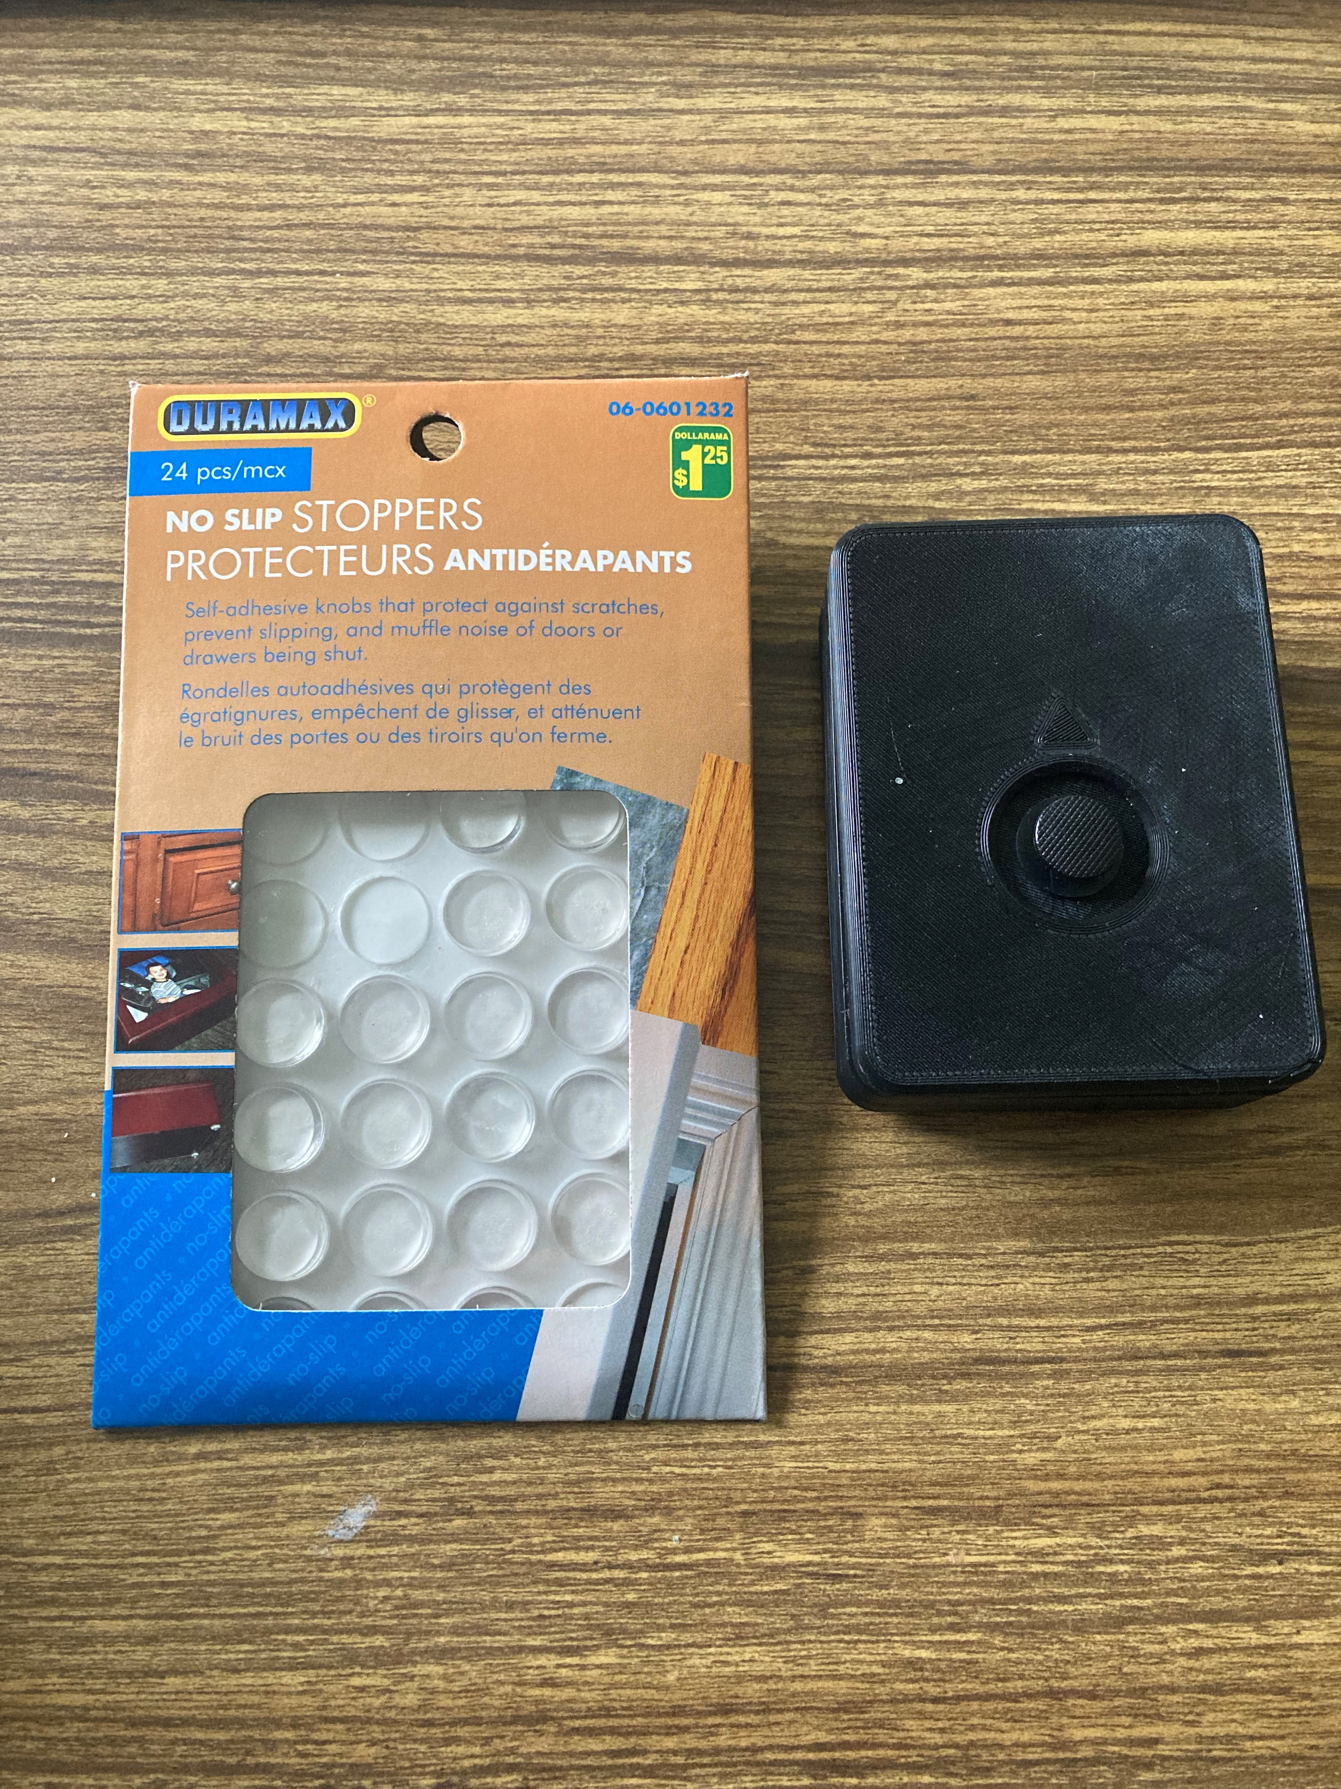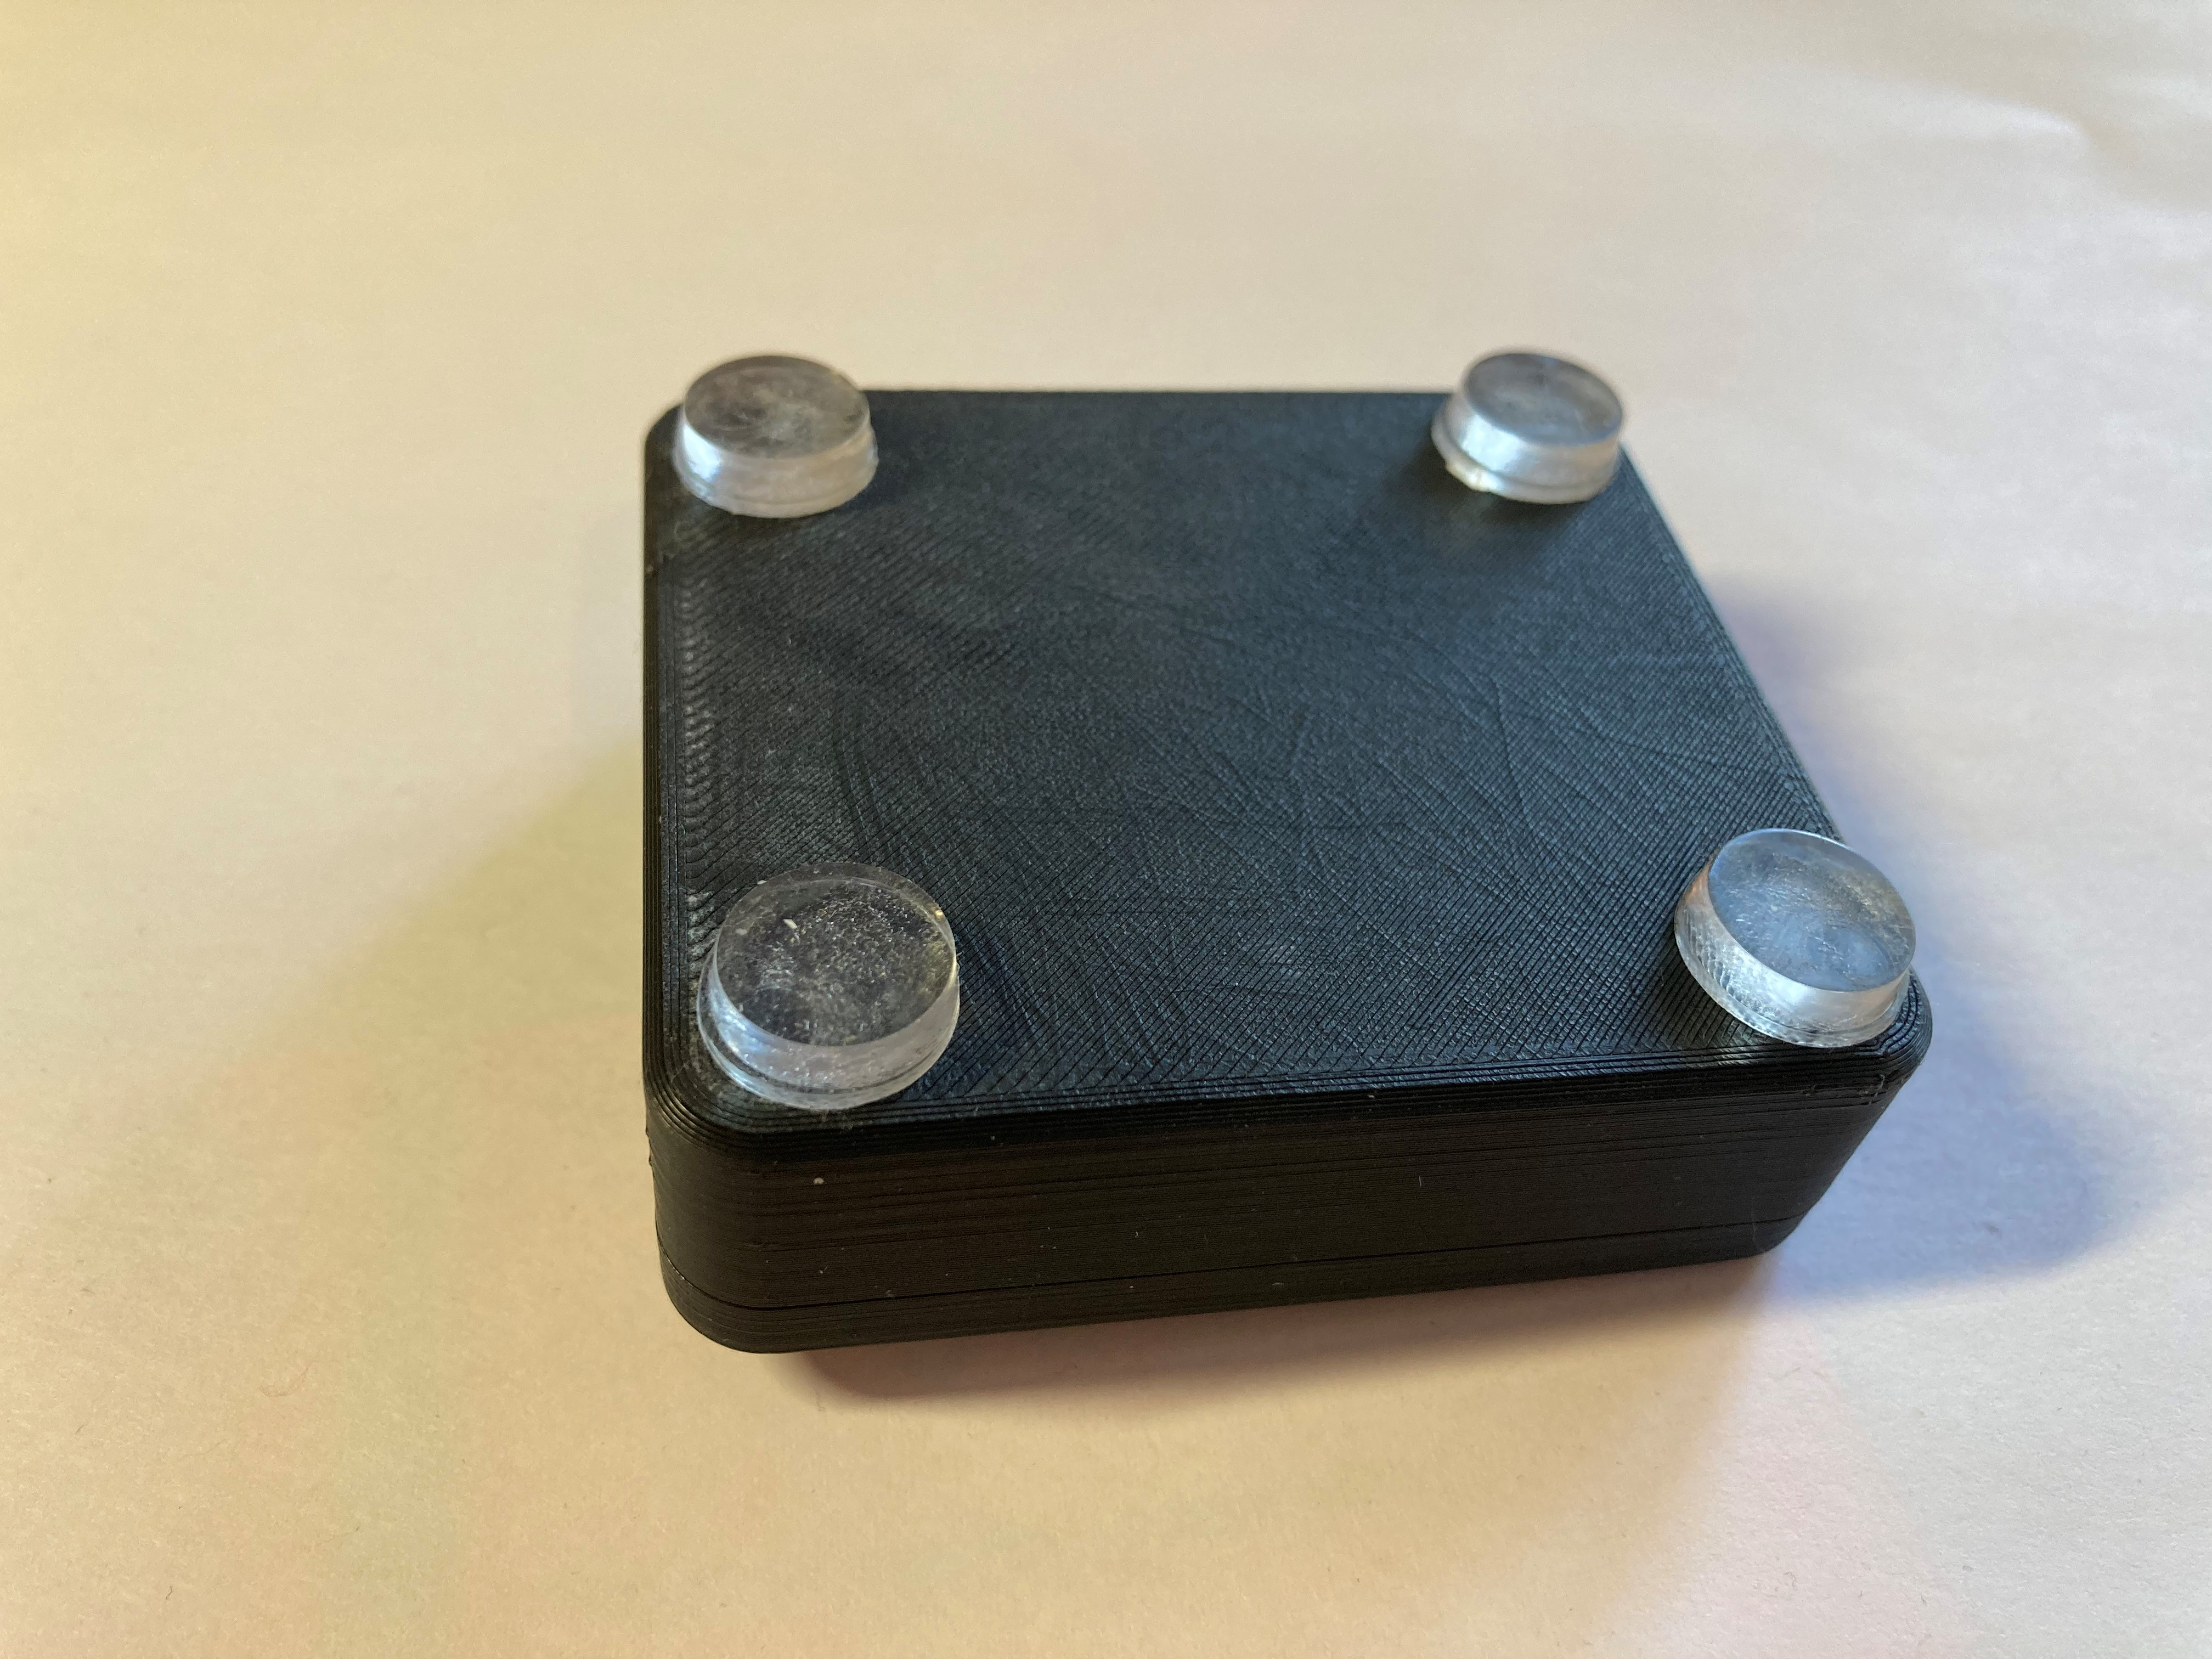

#### ¼-20 Threaded Camera Mount

Another way the joystick can be mounted, is by using a mount with a ¼-20 thread on the end, such as a commercially available camera mount. To mount the joystick on a ¼-20 thread, the Camera Mount Adapter is used. The assembly for this Camera Mount Adapter is found in the Assembly Guide.

Camera Mount Adapter:

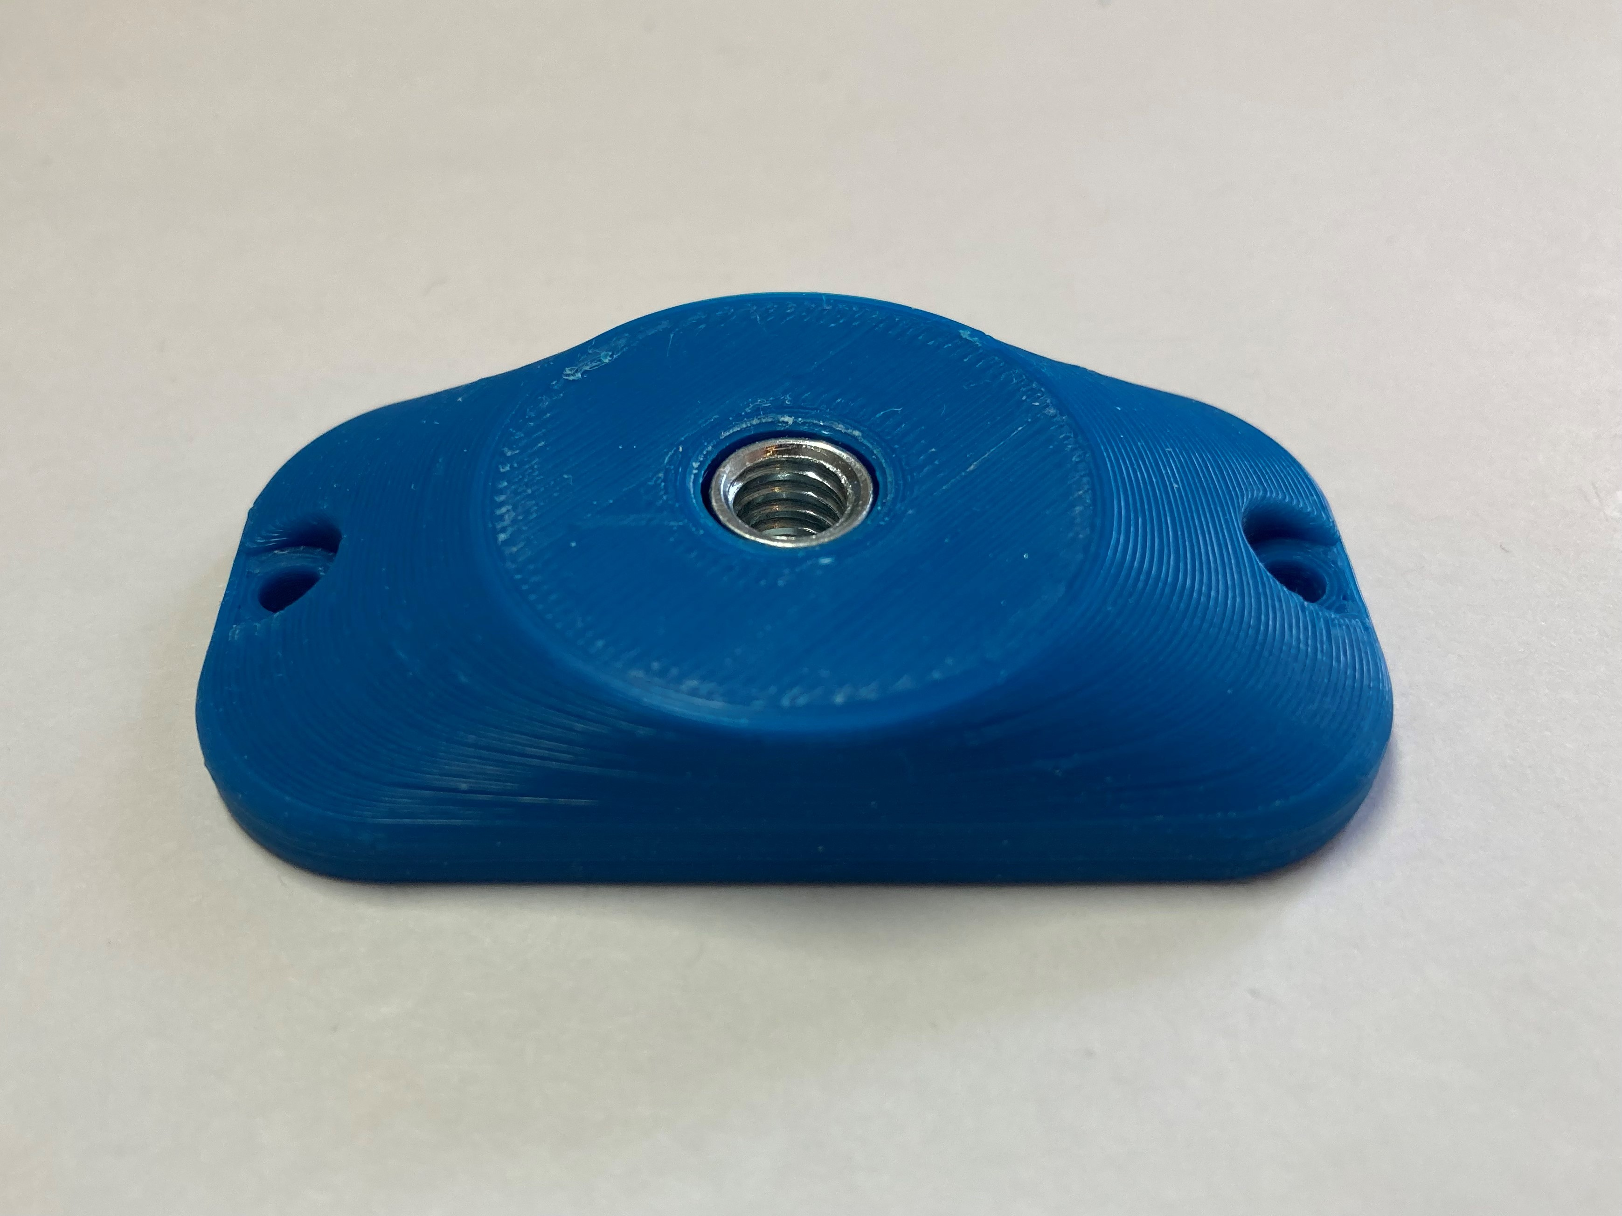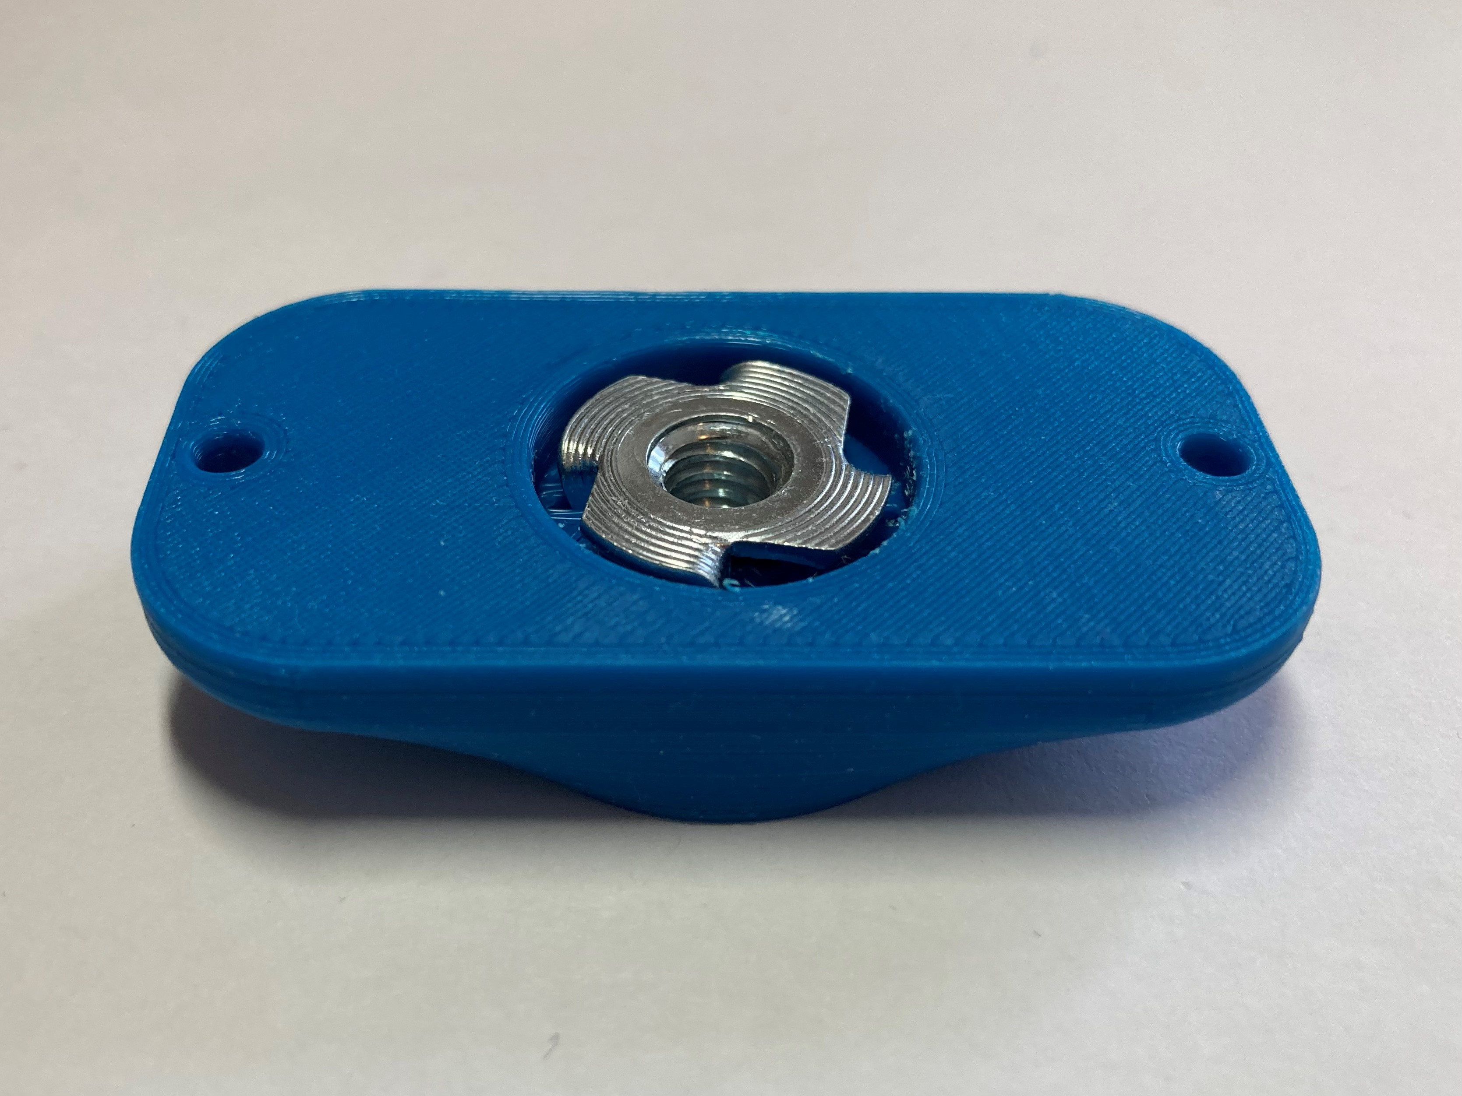

This is then screwed onto the bottom of the joystick, as shown below, using two M3 screws that are at least 10 mm long. Now, the joystick can be mounted on a mount with ¼-20 thread, such as a typical camera mount.

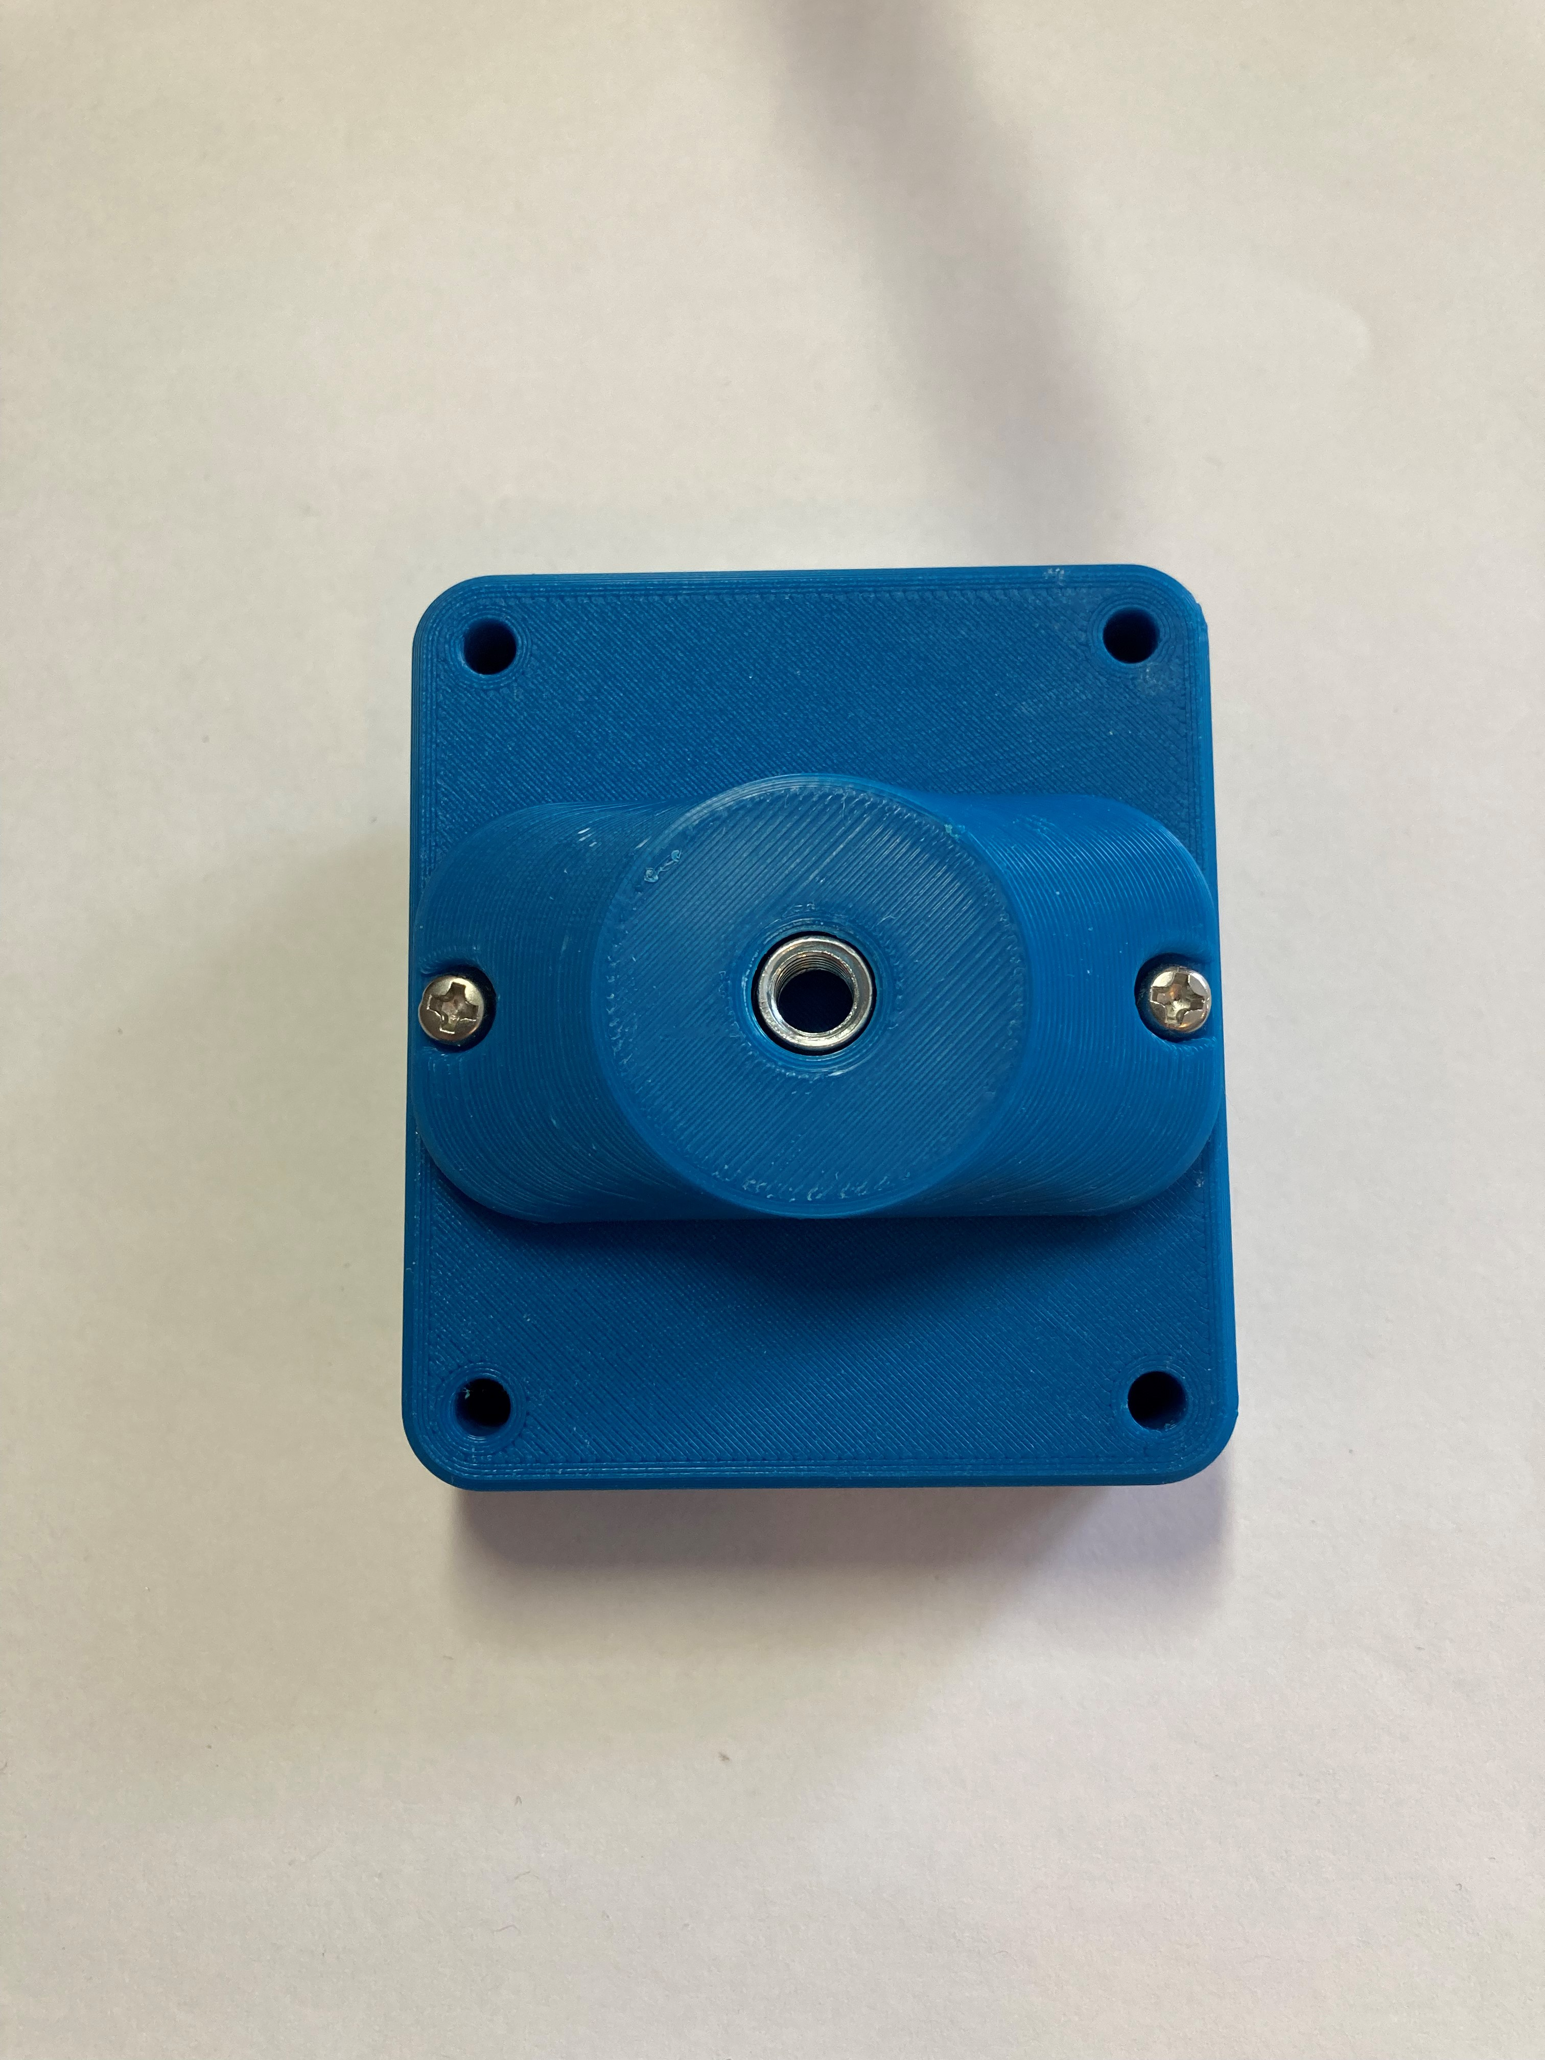

## Specifications

|  |  |
| --- | --- |
| Total height (with default topper) | 4.0 cm |
| Enclosure height | 2.7 cm |
| Enclosure width | 7.0 cm |
| Enclosure length | 7.0 cm |

## Cleaning

The Cedar Mini Joystick can be wiped down with a damp cloth. Do not use hot water on this device or the plastic housing may warp. Do not submerge the device.